Lab 4 Lessons learned from the school of hard knocks.



<https://blog.contactcenterpipeline.com/2017/07/the-school-of-hard-knocks-are-you-a-graduate/>

<https://www.azquotes.com/quotes/topics/school-of-hard-knocks.html>

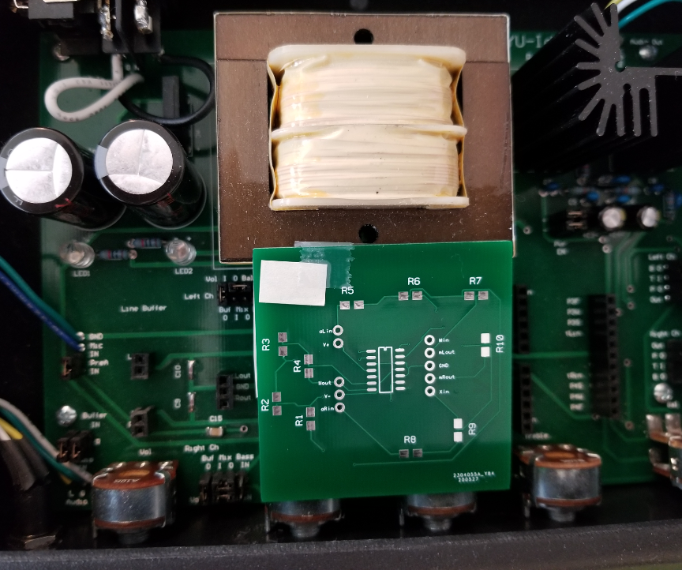

Figure 1 Outline of this Mixer PCB is 2”x2” which does not fit on the motherboard.

Connecting wires will need to be used for the Mixer PCB headers pins to reach the motherboard headers.

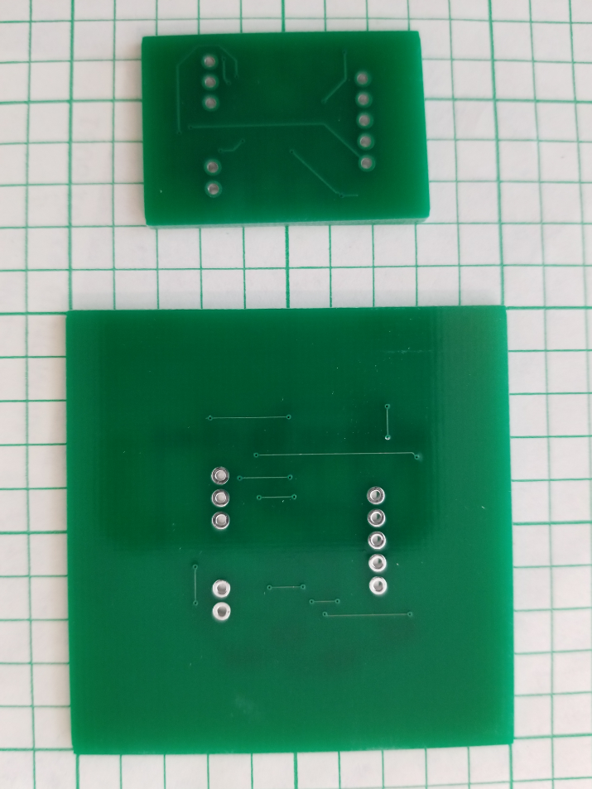

Figure 2 Comparison of largest mixer PCB outline with the smallest mixer PCB outline designed in ECEN 250 S20.